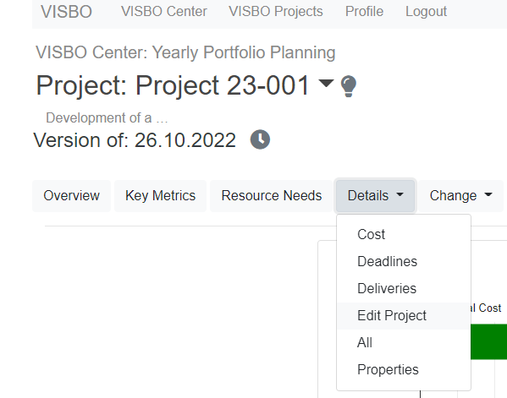
Project Edit - User's Guide

Editing projects with Excel Frontend directly from the VISBO web interface

Copyright VISBO 2022
Table of contents
Summary 3
Edit dates 4
Edit resource requirements 7
Edit cost requirements 9
The settings 11
Save and load 12
Error management 12

Summary

Via the VISBO web user interface, an Excel Front End can be called up, with which
- the dates of the project phases and milestones as well as their traffic light statuses, explanations, scopes of delivery and, if applicable, invoices and penalties attached to the milestone
- the monthly resource requirements
- the monthly cost requirements
can be entered or changed.

Prerequisites:
The following is installed on the user's client computer
- VISBO SPE (Simple Project Edit) Excel Add-In
- VISBO Connect (for establishing a connection between browser and Excel add-in)
- In VISBO Center the setting "CustomEdit" is present and created. If it is not, ask VISBO to do it for you.

Edit dates
The initial view is always the appointment view.

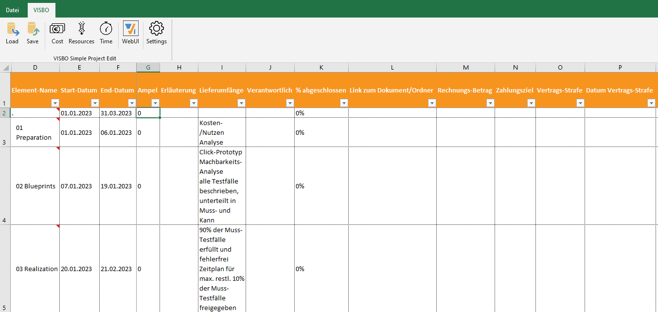

Here you can change the following values:
- Start date
- End date
- Traffic light: 0 = no evaluation; 1=green; 2=yellow; 3=red
- Explanation: Free text to explain the traffic light
- Scope of supply: free designation of the scope of supply in one word if possible; separate several scopes of supply by a LineFeed (Alt-Enter) within the Excel cell.
- Responsible: Freit-Text , contact person for this milestone, this phase
- %completed: Value between 0 and 1; 1=means the work is completed, the milestone has been reached.
- Link to the documents folder: preparation to be included in an upcoming version of
- (optional) Invoice amount in T€ due at this milestone, at the end of the phase.
- (optional) payment term in days, when the payment can be expected to be received
- (optional) possible contractual penalty in € thousand if the milestone date is not reached until after the date of the contractual penalty.
- (optional) Date penalty; specifies the date from which a penalty is due if the milestone or end of phase is not reached by this date.

Notes:
- You can change all the displayed values of existing milestones and phases, unless actual data has already been imported. Then, only the dates after the date up to which actual data has been imported can be changed. Example: Actual data was imported up to and including Apr 2022. Dates from 1 May onwards can all still be changed. Cell contents that can no longer be changed are highlighted in gray.
- You cannot change the names of phases and milestones with the Simple Project Add-In, nor can you interactively add or delete milestones or phases. If new milestones or phases are to be added or deleted, then proceed as follows:
  - Export the profile to an offline Excel file using the Excel AddIn Projectboard.
  - Include the new phases / milestones in the Excel file or delete existing ones.
  - Use Excel AddIn Projectboard to import the modified profile again.
Please always be aware that the basic concept of VISBO is to compare the current planning status with the commissioned planning status ("baseline") at any time. If you rename, add or delete milestones/phases during the course of the project, then the comparability of the two planning statuses is reduced accordingly. The recommendation is to focus on the management relevant milestones and phases from the beginning. And then always update their values over the course of the project. This gives you the best basis for trend analyses and lessons learned. Therefore, in VISBO online it is not even possible to change, add or delete the names of phases and milestones. If it is necessary, please proceed as described a few lines above.
- The optional columns are only visible if the option "Invoices and Penalties" has been activated in Settings. If you activate this option in the view "Appointments", you have to switch to the view "Resources" or "Costs" and then back to "Appointments" to make the optional columns visible and editable.

Tips and important notes when changing appointments:
Select Start or End date cell and press the right mouse button. You can then select the appropriate start or end date for the corresponding phase or milestone. The phase named "." represents the whole project.

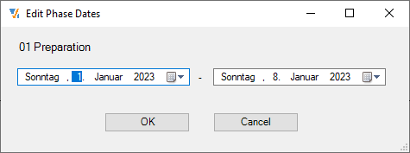
Effects of date change on dates of subordinate elements
"Date changes also affect the subordinate tasks: Default = On.
A default in the settings is "Date changes also affect the subordinate tasks". This means that if you move the project end date back by two months, for example, the dates of the "child elements", i.e. the phases and milestones belonging to the project, will be adjusted proportionally. This applies only to the dates that are not in the period where actual data are already available. If the child phases / milestones should remain unchanged by the date, please set the corresponding value in the settings to Off.
Effects of deadline change on resource distribution
"Distribute values automatically over time": Default = On.
Another setting that has an effect when dates are changed is "Distribute values automatically over time". The default is "On". This value refers to how resources and cost requirements are handled when, for example, a certain phase is shortened or extended. The default value means that the required number of person-days remains the same, but the distribution over the months may change. An example: a phase runs from 1.3.2022 to 22.3.2022 and requires 100 PT. If the end date is now moved to 4/14/2022, then the value of 100 PT is now distributed over the months of March and April, according to the number of working days available in the months. The total effort for the phase remains the same, only the distribution of the effort over the months changes accordingly.

"Adjust resource needs proportionally ": Default = Off.
This setting affects whether resources and cost requirements are increased or decreased proportionally with the shortening/extension of a phase or the entire project.

Edit resource requirements
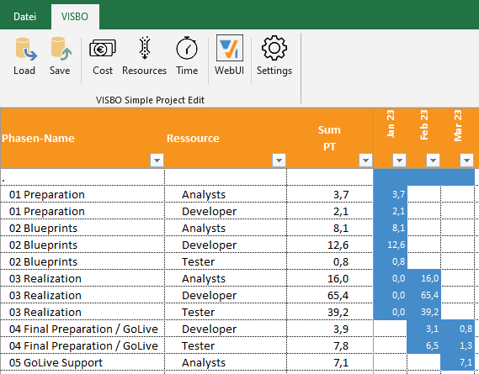

You can make entries in the columns:
- Resource
- Sum (PT)
- Month columns

You can right-click in the column Phases Name
- Add an empty line
- Delete an existing line

Input in "Resource" column
- Right-click in an empty cell to display the entire resource pool. Expand the resource pool and select one or more resources.
- Right-click in a cell with an existing entry (e.g. "Analysts") to display the partial resource tree, i.e. all employees of the "Analysts" department.
- Specify an identifier or only a part of an identifier of a resource. In case of uniqueness, the corresponding resource will be entered immediately. If several resources contain this partial string, you will be shown a selection list.
- Double-click in a cell with an existing entry (e.g. "Analyst") to display a list of people who have this role or skill. It will also show you how much capacity these people have in the required time period.
Note: In the current version of Simple Project Edit, the "Plan-in-Context" functionality is not yet enabled, which calculates the free capacity also taking into account all other, already running projects. This functionality is currently only available in the Projectboard Premium Excel Add-In.

Input in column "Sum PT
- Only values > 0 can be entered. The unit is always "person days".
- The value you enter here will be distributed over the months that the corresponding phase spans. The distribution of the total roughly takes into account the working days that lie in the period. (only distinction working day vs weekend; no consideration of country-specific holidays).
- A value larger than the total capacity of the resource in the period is reduced to the total capacity available in the period. If you still want to force larger values, you can do so by entering them in the month columns.
- The cell is locked if the phase already contains actual data (marked in gray). You must then make the entries in the individual month columns marked in blue.
Input in single month columns
- Only values > 0 can be entered. The unit is always "person days".
- Basically, values can only be entered in cells marked "blue". Cells without color have no meaning and are locked because the corresponding phase does not contain this month at all.
- You can also enter values here that are significantly higher than the capacity of the resource in that month.

Edit cost requirements
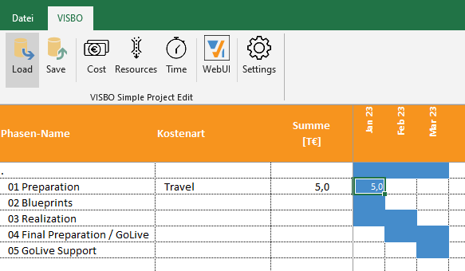
You can make entries in the columns:
- Cost type
- Sum (€k)
- Month columns

You can right-click in the column Phases Name
- Add an empty line
- Delete an existing line

Input in column "Cost type
- Right-click in an empty cell shows you the defined cost types.
- Enter an identifier or only a part of an identifier of a cost element. If it is unique, the corresponding cost element will be entered immediately. If several cost elements contain this partial string, you will be shown a selection list.
Input in column "Sum T€
- Only values > 0 can be entered. The unit is always "Thousand Euro (T€)".
- The value you enter here will be distributed over the months that the corresponding phase spans.
- The cell is locked if the phase already contains actual data (marked in gray). You must then make the entries in the individual month columns marked in blue.
Input in single month columns
- Only values > 0 can be entered. The unit is always "Thousand Euro (T€)".
- Basically, values can only be entered in cells marked "blue". Cells without color have no meaning and are locked because the corresponding phase does not contain this month at all.

The settings
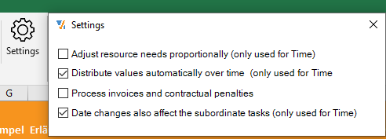

Adjust resource need proportionally
Default = Off.
This setting affects whether the resources and cost requirements are proportionally increased or decreased with the shortening / extension of a phase or the entire project. With Defualt = Off, the total number of person-days required for the phase remains the same, regardless of whether the phase lasts 2 weeks or 2 months. Otherwise, the resource requirement is adjusted proportionally: 10% longer = 10% more resource effort.

Distribute values automatically over time
Default = On.
This value refers to how resources and cost requirements are handled if, for example, a certain phase is shortened or extended. The default value means that the required number of person-days remains the same, but the distribution over the months may change. An example: a phase runs from 3/1/2022 to 3/22/2022 and requires 100 PT. If the end date is now moved to 4/14/2022, then the value of 100 PT is now distributed over the months of March and April, according to the number of working days available in the months. The total effort for the phase remains the same, only the distribution of the effort over the months changes accordingly.

Process invoices and contractual penalties
Default = Off
These columns are only visible in the view mode "Appointments" if the option "Invoices and Penalties" has been activated. If you activate this option in the "Appointments" view, you must first switch to the "Resources" or "Costs" view and then back to "Appointments" so that the optional columns are visible and editable.

Date changes also affect subordinate tasks
Default = On.
This means that if you move the project end date back by two months, for example, the dates of the "child elements", i.e. the phases and milestones belonging to the project, are adjusted proportionally. This applies only to the dates that are not in the period where actual data are already available. If the child phases / milestones should remain unchanged by the date, please set the corresponding value in the settings to Off.

Save and load
With Save / Save you save the changes in the VISBO Cloud.

With Load you can explicitly load one or more projects. Attention: the previously loaded project(s) will be deleted from the session. If necessary, save before loading further, i.e. other projects.

Important note: when you return to the Web UI, you must do a "Browser Refresh" to see the updated data. Otherwise, they will continue to see the metrics of the version of the project as it was before the Project Edit.

Error management
If errors occur, there are logfiles for the VISBO Project Edit, as well as for the Connect-Tool. These are located under c:\user\<username>\AppData\Roaming\VISBO\...
Furthermore it is necessary that the settings for the connection contained in vcn_config.json are set correctly.
These are the specifications for the location of the EXCEL.EXE and for the VISBO Project Edit.xlsx - file belonging to the ExcelAdd-In.

